Assignment 1: Is the temperature changing?

## 3

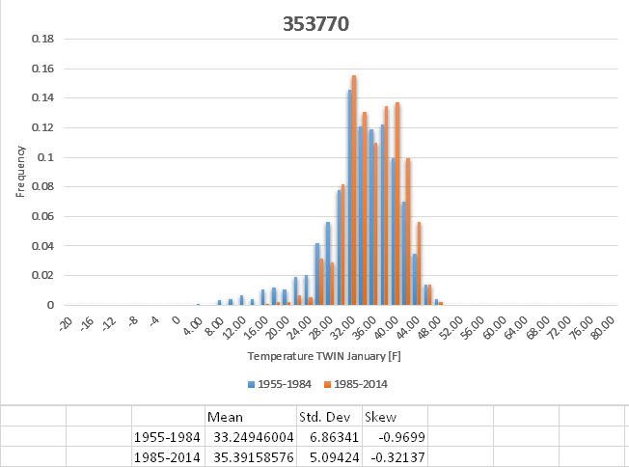

The data set from 1955-1984 has a mean of 33.25 and a median of 34, measurably cooler than 1985-2014, which saw a mean of 35.4 and a median of 35. 1955-1984 saw more variability, with a standard deviation of 6.86, while 1985-2014 had 5.1. A contributing factor is significant decrease in sub-30 degree weather. While 1955-1984 had a left-word skew of -.97, 1985-2014 just had -0.32.

## 4

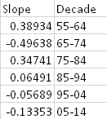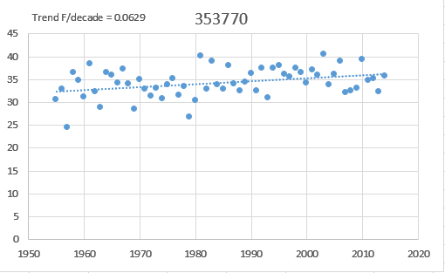

5. I’ll guess this is located in Kentucky, as its high enough in the US to get cold winters but not real freezing.

Nope, I was totally wrong, and underestimated the temperature of the northern US. Portland Oregon.

6. <http://w2.weather.gov/climate/index.php?wfo=pqr>.

2016: 45.7

2017: 39.9

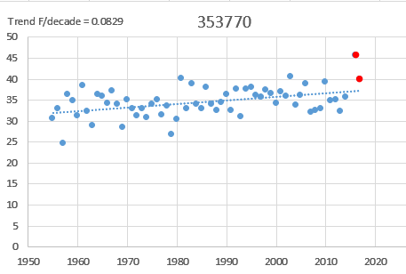

7. As previously stated, the mean marginally increased, and the standard deviation significantly decreased. Portland’s temperature increase was just .08F a decade, so less than average, but still there. Yes, my analysis relatively supports climate change, in that Portland saw its climate marginally become warmer. Yes, it might apply to my station, as Portland has significantly grown throughout the decades.